MindMate — Phase Three: Analysis Phase
Oct 8, 2026

3.1 Introduction
The Analysis Phase confirms what MindMate must do by studying how students get mental health support today and where that process fails them. Phase One identified the need: 24.4% of surveyed South African students had considered suicide in the past 30 days, yet only 21.3% of those with a diagnosable disorder received treatment (Bantjes et al., 2013). Phase Two planned the project and drafted an initial Software Requirement Specification and data model.
This phase moves from planning to evidence. It covers:
- How the team gathered information (observation, participatory sessions and interviews).
- How the existing support system works, and the data it handles.
- The weaknesses of that system that MindMate must address.
- The refined functional and non-functional requirements of the proposed system.
- A normalised data model and entity relationship diagram (ERD) that the Design Phase will build on.
The analysis keeps the principles set in Phase One: MindMate is non-clinical, offline-first, privacy-first and POPIA-compliant, and it always points students to real professional help when they are at risk.

3.2 Information Gathering Methodology
The team used three complementary methods so that each finding could be checked against at least one other source. Observation showed what students actually do, interviews explained why, and participatory sessions let students shape the solution directly. Secondary research from Phases One and Two (the national student survey, the Wits University study and a review of comparable apps) was used to compare and confirm what the three methods found.
Method | Who was involved | What the team did | What it fed into
Observation | Students on campus; the campus counselling / student wellness office | Noted how a student finds and books counselling: signage, opening hours, booking steps, walk-in vs appointment, and what happens after hours. Also observed team members and peers using two existing wellness apps on entry-level phones. | 3.3 Existing system, 3.5 Weaknesses, NFR targets for device performance
Participatory | [n] student volunteers from different years and faculties | Card-sorting session on the ten problem categories from Phase One, and a paper walkthrough of onboarding, mood check-in and the crisis button. Students changed wording, order and screen flow on the spot. | FR2 onboarding, FR7 For You page, 3.7 usability and tone requirements
Interviews | [n] students; [n] campus counsellor or wellness staff member | Semi-structured interviews of 15 to 20 minutes, using the guide below. Notes were taken with consent and no names were recorded. | 3.3, 3.5, crisis escalation rules (FR10), referral directory (FR9)

Observation
Observation was passive: team members watched and recorded the support process without taking part in it. This avoided the bias of students describing an ideal process rather than the real one. The team recorded the counselling office's hours (weekdays, 13:00 to 17:00 as noted in Phase One), how a student books a session, and what information is visible to a student who arrives after hours.

Participatory sessions
In participatory design, the future users help build the solution. Students sorted problem cards into the categories they felt matched their own situation, which tested whether the ten categories were clear and complete. A paper prototype was then used to walk through the main flows. This method was chosen because MindMate's value depends on students trusting it, and students are best placed to judge tone and privacy.

Interviews
Interviews were semi-structured: a fixed set of questions with room for follow-up. Separate guides were used for students and staff.
Student interview guide
- When you are stressed or struggling, where do you go for help first?
- Have you ever used campus counselling? What made it easy or hard?
- What stops students from asking for help?
- At what times of day or year do you feel the most pressure?
- Would you use a mental health app? What would make you trust it with your information?
- How reliable is your mobile data, and do you use apps offline?
- Would you share your experiences in an anonymous student community?
Counsellor / staff interview guide
- How does a student book a session, and how long do they usually wait?
- How are student records kept, and who can access them?
- What happens when a student is in crisis outside office hours?
- What do students most often come in for?
- What should an app never do, from a counselling point of view?

Ethics
Participation was voluntary and anonymous. No names, student numbers or health details were recorded, in line with POPIA's principle of collecting only the minimum personal data needed. Students were given the national helpline numbers at the end of each session.

3.3 Analysis of the Existing System
The existing system is not one piece of software. It is a mostly manual, in-person process built around the campus counselling office, with national helplines as the only after-hours option. A student must first know that help exists, then reach campus during a short weekday window, then book and attend a session.
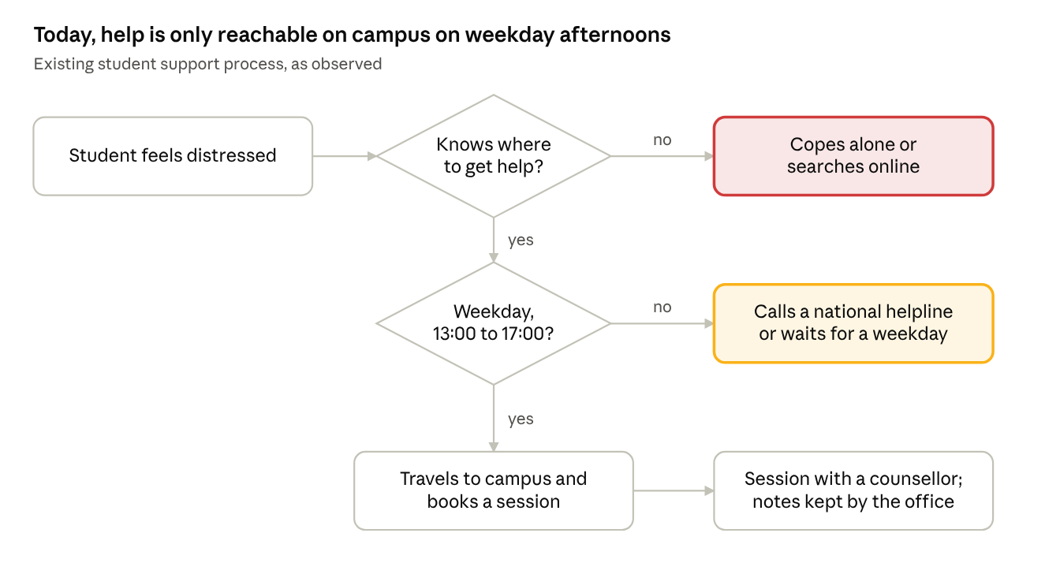
Existing support process · 2 decisions, 3 outcomes
A student only reaches a counsellor by passing both decisions; every other path ends with the student coping alone or waiting.

Components of the existing system
Component | How it works today | Data it handles
Campus counselling / student wellness office | Walk-in or booked sessions, weekdays 13:00 to 17:00. The student travels to the office. | Student name, student number, contact details, session notes, kept by the office
National helplines | Phone or SMS lines available after hours. The student must already know the number. | Caller details as given on the call; nothing is shared with the university
Peers and friends | Informal support. Often the first place students turn, as noted in Phase One. | None recorded
Online search and general wellness apps | Generic content, often data-heavy, not tailored to South African students or their specific problem. | Varies by app; often requires an account and personal details
Posters, orientation talks, student portal | One-way information about services and helpline numbers. Updated manually. | None

Inputs, processes and outputs
Stage | Detail
Input | A student in distress; the student's own knowledge of where help is; available time and transport
Process | Find the service, travel to campus, book a session, attend, follow up by a new booking
Output | Counselling session and the counsellor's notes, or a referral; otherwise no recorded outcome
Storage | Session records kept by the counselling office; nothing is held by the student

Summary
The existing system works well for a student who knows about it, can reach campus in office hours, and is comfortable walking into a counselling office. It does not serve students who are unsure where to go, feel stigma, struggle at night or during exams, or have limited data and transport. These gaps are listed in Section 3.5.

3.4 Data Analysis (Data Integrity and Constraints)
Most of the data MindMate holds is highly sensitive, so integrity and privacy rules are designed into the database rather than left to the app code. The analysis below classifies each type of data, sets the integrity rules, and lists the constraint on every attribute. The database is SQLite on the device (Phase One), so types are SQLite types and dates are stored as ISO 8601 text.

Data classification
Data | Sensitivity | Where it is stored | How it is protected
Journal entries | Very high | Device only; optional encrypted backup | End-to-end encrypted; developers cannot read it
Mood entries and notes | High | Device; synced only for registered users | Encrypted at rest with a key in the Android Keystore
Selected problem categories | High (reveals a mental health concern) | Device; synced only for registered users | Encrypted at rest; never shown to other users
Assessment results | High | Device | Encrypted at rest; wording is non-diagnostic
Community posts and stories | Medium (shared, pseudonymous) | Server | Encrypted in transit (TLS); moderated; no real names
User profile (display name, age range) | Low | Device; server if registered | Optional fields; no real name or date of birth
Reminders | Low | Device | Local only
Resource articles and referral contacts | Public | Bundled in the app; updated by remote configuration | Read-only to students; versioned

Integrity rules
Integrity type | Rule | How MindMate applies it
Entity integrity | Every table has a primary key that is unique and never null. | Keys are UUIDs generated on the device, so records created offline never clash when they sync.
Referential integrity | Every foreign key must match an existing primary key. | A mood entry cannot exist without its user. Deleting an account cascades to all of that user's private data (POPIA right to erasure). Community posts are kept but anonymised (UserId set to null).
Domain integrity | Every value must come from its allowed set or range. | Mood is 1 to 5; InputMethod is Text or Voice; AccountMode is Guest or Registered; age is a range, not a date of birth.
User-defined (business) rules | Rules that come from the requirements, not from the data type. | Journal text is never stored in plain text. Guests cannot post to communities. Timestamps cannot be in the future. Only an administrator can change referral contacts.

Data dictionary and constraints
Entity | Attribute | Type | Constraints
User | UserId | TEXT (UUID) | PK, NOT NULL
User | DisplayName | TEXT | NULL allowed; max 30 characters; no real name required
User | AgeRange | TEXT | NULL allowed; IN ('17-19', '20-22', '23-25', '26+')
User | AccountMode | TEXT | NOT NULL; IN ('Guest', 'Registered'); default 'Guest'
User | CreatedAt | TEXT (date-time) | NOT NULL; default current time
ProblemCategory | CategoryId | INTEGER | PK; 1 to 10
ProblemCategory | Name | TEXT | NOT NULL; UNIQUE (e.g. Academic pressure, Financial stress)
UserProblem | UserId | TEXT | PK (composite), FK to User; ON DELETE CASCADE
UserProblem | CategoryId | INTEGER | PK (composite), FK to ProblemCategory
MoodEntry | MoodEntryId | TEXT (UUID) | PK
MoodEntry | UserId | TEXT | FK to User; NOT NULL; ON DELETE CASCADE
MoodEntry | MoodValue | INTEGER | NOT NULL; CHECK 1 to 5
MoodEntry | NoteEncrypted | BLOB | NULL allowed; encrypted
MoodEntry | CreatedAt | TEXT (date-time) | NOT NULL; not in the future
JournalEntry | JournalEntryId | TEXT (UUID) | PK
JournalEntry | UserId | TEXT | FK to User; NOT NULL; ON DELETE CASCADE
JournalEntry | ContentEncrypted | BLOB | NOT NULL; end-to-end encrypted
JournalEntry | InputMethod | TEXT | NOT NULL; IN ('Text', 'Voice')
JournalEntry | CreatedAt | TEXT (date-time) | NOT NULL; not in the future
Assessment | AssessmentId | INTEGER | PK
Assessment | CategoryId | INTEGER | FK to ProblemCategory; NOT NULL
Assessment | Title | TEXT | NOT NULL
Assessment | Version | INTEGER | NOT NULL; at least 1
AssessmentResult | ResultId | TEXT (UUID) | PK
AssessmentResult | UserId | TEXT | FK to User; NOT NULL; ON DELETE CASCADE
AssessmentResult | AssessmentId | INTEGER | FK to Assessment; NOT NULL
AssessmentResult | Score | INTEGER | NOT NULL; 0 or more
AssessmentResult | ResultSummary | TEXT | NOT NULL; non-diagnostic wording only
AssessmentResult | CompletedAt | TEXT (date-time) | NOT NULL
ResourceArticle | ResourceId | INTEGER | PK
ResourceArticle | CategoryId | INTEGER | FK to ProblemCategory; NOT NULL
ResourceArticle | Title, BodyText | TEXT | NOT NULL; plain text, no images required
ResourceArticle | Version | INTEGER | NOT NULL; at least 1
CommunityGroup | GroupId | INTEGER | PK
CommunityGroup | CategoryId | INTEGER | FK to ProblemCategory; NOT NULL
CommunityGroup | Name | TEXT | NOT NULL; UNIQUE
CommunityPost | PostId | TEXT (UUID) | PK
CommunityPost | GroupId | INTEGER | FK to CommunityGroup; NOT NULL
CommunityPost | UserId | TEXT | FK to User; NULL allowed; ON DELETE SET NULL (post is anonymised)
CommunityPost | PostType | TEXT | NOT NULL; IN ('Post', 'Story')
CommunityPost | Content | TEXT | NOT NULL; 1 to 1,000 characters
CommunityPost | Status | TEXT | NOT NULL; IN ('Visible', 'Flagged', 'Removed'); default 'Visible'
CommunityPost | CreatedAt | TEXT (date-time) | NOT NULL
Reminder | ReminderId | TEXT (UUID) | PK
Reminder | UserId | TEXT | FK to User; NOT NULL; ON DELETE CASCADE
Reminder | Type | TEXT | NOT NULL; IN ('Check-in', 'Journal', 'Deadline', 'Custom')
Reminder | TimeOfDay | TEXT (HH:MM) | NOT NULL
Reminder | RepeatRule | TEXT | NOT NULL; IN ('None', 'Daily', 'Weekly')
ReferralContact | ReferralId | INTEGER | PK
ReferralContact | Type | TEXT | NOT NULL; IN ('Campus counselling', 'National helpline', 'Emergency')
ReferralContact | Name, PhoneNumber | TEXT | NOT NULL; phone number digits only
ReferralContact | Hours | TEXT | NOT NULL (e.g. '24/7' or 'Mon-Fri 13:00-17:00')
ReferralContact | UrgencyLevel | TEXT | NOT NULL; IN ('Low', 'Medium', 'High')
ReferralContact | Version | INTEGER | NOT NULL; raised on every update

3.5 Weaknesses of the Current System
The current system's main weakness is that it is only reachable in person, on weekday afternoons, by students who already know it exists. The survey finding that only 21.3% of students with a diagnosable disorder received treatment (Bantjes et al., 2013) shows the scale of the gap. Each weakness below is mapped to the MindMate requirement that addresses it.
No. | Weakness | Effect on students | Addressed by
W1 | Limited hours: counselling runs weekdays 13:00 to 17:00 only. | Distress peaks at night, during exams and around results, when the office is closed. | FR3, FR10, NFR6 (24/7 offline self-help)
W2 | Low awareness: students must already know where help is. | Students who do not know the service cope alone or rely on unreliable online advice. | FR9 referral directory, crisis button on every screen
W3 | Stigma: help means visibly walking into a counselling office. | Fear of being seen or of academic consequences stops students from going. | FR1 guest mode, FR3 private journaling, NFR2 and NFR3 privacy
W4 | Physical access: travel to campus is needed. | Transport costs and timetable clashes block access, especially for off-campus students. | FR3, FR6 (help on the phone, offline)
W5 | Generic information: posters and general apps are not specific to the student's problem. | Content feels irrelevant and is ignored. | FR2 problem categories, FR6 resources, FR7 For You page
W6 | No peer support channel: peers are students' first choice, but there is no safe, moderated space. | Students feel isolated, especially first-years and out-of-town students. | FR7 communities, FR8 Stories, FR13 moderation
W7 | No urgency triage: every request follows the same booking process. | A student in crisis gets the same path as a student with mild stress. | FR10 urgency-based responses and escalation
W8 | Manual, slow updates: helpline numbers are on posters and web pages updated by hand. | Out-of-date numbers in a crisis. | FR11, NFR8 externally configurable contacts
W9 | No self-tracking: the student holds no record of their own mood or progress. | Students cannot notice patterns or show a counsellor how they have been. | FR3 mood tracking, FR12 personal insights
W10 | Data cost: general wellness apps are data-heavy and assume constant connectivity. | Only 80.8% of students have reliable mobile data (Phase One). | NFR1 offline core, NFR4 small app size

3.6 Analysis of the Proposed System (Functional Requirements)
The proposed system is MindMate: an offline-first Android app that gives students private self-help at any hour, content specific to their problem, a moderated peer community, and a clear path to professional help. The functional requirements below refine the eleven drafted in Phase Two and add five that came out of this analysis (FR12 to FR16). Priorities use MoSCoW (Must, Should, Could have).

Actors
Actor | Description
Guest student | Uses the app without an account. Has all offline features; cannot post in communities or sync.
Registered student | Has a pseudonymous account. Can join communities, post stories and back up data.
Moderator | Trained student volunteer or staff member who reviews flagged community posts.
Content administrator | Updates resource articles and referral contacts through remote configuration.

Functional requirements
ID | Requirement | Actor | Priority | Iteration
FR1 | The system shall let a student register, log in, or continue as a guest without giving personal data. | Student | Must | 1
FR2 | During onboarding, the student shall select one or more of the ten problem categories from Phase One; these can be changed later. | Student | Must | 1
FR3 | The system shall record mood check-ins (scale of 1 to 5 with an optional note) and journal entries, fully offline and without an account. | Student | Must | 1
FR4 | The system shall provide an AI chatbot that gives quick, supportive, non-diagnostic responses and suggests relevant app content. | Student | Should | 3
FR5 | The system shall allow a journal entry to be dictated using voice-to-text. | Student | Could | 2
FR6 | The system shall provide a text-first resource library bundled in the app, filtered by the student's problem categories. | Student | Must | 2
FR7 | The system shall provide a For You page and community groups that connect registered students with the same problem category. | Registered student | Should | 3
FR8 | The system shall provide a Stories section where registered students share how they reached a mental health goal. | Registered student | Could | 3
FR9 | The system shall provide a referral directory (campus counselling, national helplines, emergency) and a crisis button on every screen. | Student | Must | 3
FR10 | The system shall vary its response to urgency, using the rules in the table below, and escalate to professional or emergency contacts when risk is indicated. | Student | Must | 3
FR11 | The content administrator shall be able to update helpline and referral details without a new app release. | Content administrator | Must | 3
FR12 | The system shall show the student a private history of their moods (weekly and monthly view) to help them notice patterns. | Student | Should | 2
FR13 | Registered students shall be able to report a post; moderators shall be able to hide or remove it; posts containing crisis phrases shall trigger the crisis screen for the author. | Registered student, Moderator | Must (if FR7 is built) | 3
FR14 | The system shall send optional reminders (daily check-in, journaling, deadlines) and rotate check-in questions so they do not repeat day to day. | Student | Should | 2
FR15 | The student shall be able to upgrade from guest to registered without losing data, and to export or permanently delete all their data (POPIA). | Student | Must | 3
FR16 | The system shall provide short self-assessments per problem category and show a non-diagnostic summary with suggested resources. | Student | Must | 2

Urgency rules for FR10
Urgency level | Trigger | System response
High | Student taps the crisis button, selects "I am not safe", or the chatbot or a post contains crisis phrases | Show the crisis screen at once: emergency and 24-hour helpline numbers with one-tap calling. Calming content is not shown first.
Medium | Mood of 1 or 2 logged on three days in a row, or a self-assessment summary indicating high distress | Suggest campus counselling with its hours and booking details, alongside coping tools.
Low | App used late at night (22:00 to 05:00) or during the student's exam period | Offer breathing exercises, grounding and journaling first, with the referral directory one tap away.

Main processes of the proposed system
- Onboarding: choose guest or register, choose an age range (optional) and problem categories.
- Daily check-in: log mood, optionally add a note or journal entry; the urgency rules are checked.
- Self-help: read resources, do an exercise, or talk to the chatbot.
- Connect: read the For You page, join a group, post or share a story (registered only).
- Get help: open the referral directory or crisis screen from any page.

3.7 Non-Functional Requirements
The non-functional requirements from Phase Two are kept and each is now given a measurable target, so it can be tested in the Testing Phase. The targets are the team's proposed values and can be adjusted once the app is tested on real devices.
ID | Category | Requirement | Measurable target
NFR1 | Availability (offline) | Core features (mood tracking, journaling, resources, referral directory, crisis screen) work with no internet connection. | 100% of core features pass with flight mode on
NFR2 | Privacy and compliance | Comply with POPIA; collect only the minimum personal data; encrypt data at rest and in transit. | No real name, ID or date of birth collected; AES-256 at rest; TLS 1.2 or higher in transit
NFR3 | Security | Journal entries are end-to-end encrypted so developers cannot read them. | Journal content never leaves the device unencrypted; keys held in the Android Keystore
NFR4 | Performance and size | Small install and smooth running on entry-level Android phones. | Install size under 30 MB; cold start under 3 seconds on a 2 GB RAM phone; runs on Android 8.0 (API 26) and up
NFR5 | Accessibility | Readable, adjustable text, clear navigation and suitable colour contrast. | Text scales to 200% without breaking layout; contrast ratio at least 4.5:1 (WCAG 2.1 AA); screen-reader labels on all controls
NFR6 | Availability (24/7) | Self-help features are available at any hour, independent of counsellor office hours. | All offline features available 24/7
NFR7 | Tone and safety | The app is non-clinical and low-pressure and never presents itself as diagnosing a user. | No diagnostic terms in any result screen; all content reviewed against a wording checklist
NFR8 | Maintainability | Referral and helpline content is configured outside the app code. | Contact details updated without a new release; change visible within 24 hours of the next connection
NFR9 | Scalability and extensibility | Community and chat features can be added on an optional backend without redesigning the offline core. | Offline core runs with the backend switched off
NFR10 | Usability | A first-time user can reach help quickly. | Crisis button reachable in one tap from every screen; onboarding completed in under 2 minutes
NFR11 | Data efficiency | The app uses as little mobile data as possible. | No images or video required for core content; background sync only on Wi-Fi by default
NFR12 | Reliability | No data is lost if the app closes or the phone dies. | Entries saved on every change; zero data loss in crash testing

3.8 Data Modeling for the Proposed System
The proposed data model has 12 entities in third normal form, with every private record tied to one anonymous User and every piece of content tied to one of the ten problem categories. It refines the Phase Two model so that it can be built directly in SQLite. Attribute types and constraints are listed in the data dictionary in Section 3.4.
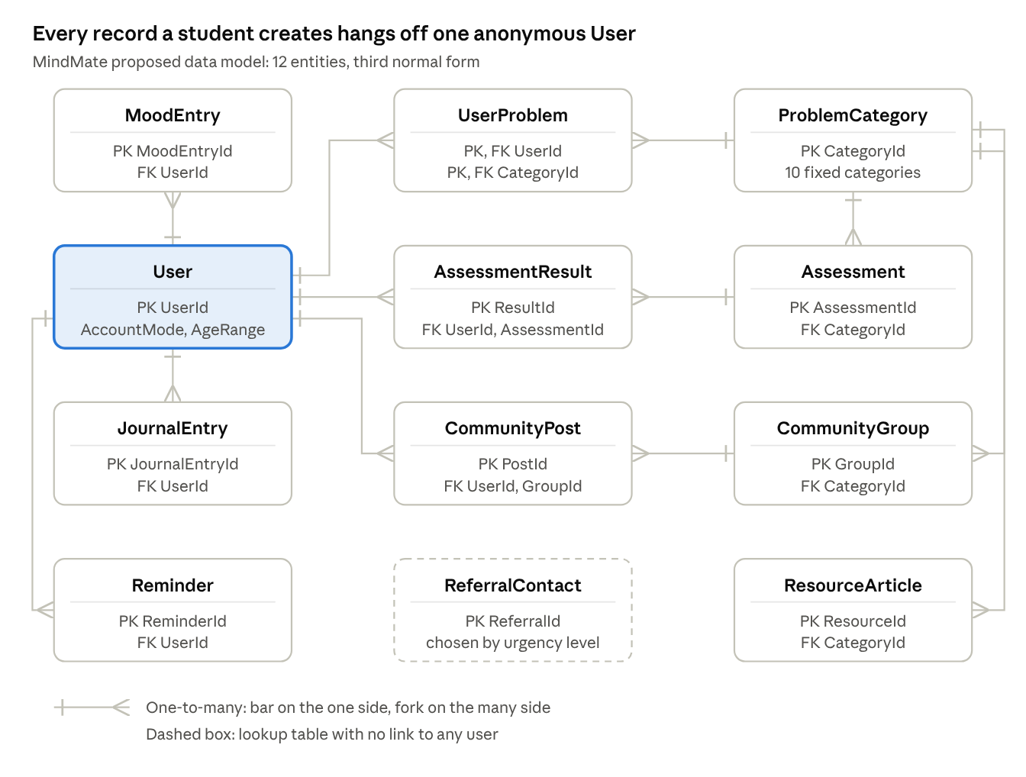
Entity relationship diagram · 12 entities, 12 one-to-many relationships
User-owned data sits on the left and is deleted with the user; shared content on the right is linked to students only through their chosen problem categories.

Relationships
Relationship | Cardinality | Meaning
User to MoodEntry | One to many | A user logs many moods; each mood belongs to one user.
User to JournalEntry | One to many | A user writes many journal entries.
User to Reminder | One to many | A user can set many reminders.
User to ProblemCategory (via UserProblem) | Many to many | A user can choose several categories; each category is chosen by many users.
ProblemCategory to Assessment | One to many | Each category has its own self-assessments.
User to AssessmentResult, Assessment to AssessmentResult | One to many (each) | Each attempt records one user taking one assessment.
ProblemCategory to ResourceArticle | One to many | Each article targets one category.
ProblemCategory to CommunityGroup | One to many | Each group is for one category, which feeds the For You page.
CommunityGroup to CommunityPost | One to many | A group holds many posts and stories.
User to CommunityPost | One to many (optional) | A registered user writes many posts; a deleted user's posts stay but are anonymised.
ReferralContact | None | Not linked to users; contacts are chosen by the urgency level from Section 3.6.

Normalisation and changes from Phase Two
- First normal form: Phase Two stored ProblemTags as a list inside User. This is a repeating group, so it is moved into the UserProblem junction table, giving one row per user per category.
- Second normal form: UserProblem has a composite key (UserId, CategoryId) and no other attributes, so there are no partial dependencies.
- Third normal form: Phase Two stored a ProblemTag on each community post. Because a post's category is already known from its group, this was a transitive dependency and is removed; the category is found through GroupId.
- Assessment split: Phase Two combined Assessment and Assessment Result. They are now two entities, so one assessment can be taken many times without repeating its title and questions.
- Stories merged into posts: Stories (FR8) are stored as CommunityPost rows with PostType = 'Story', so they share moderation (FR13).
- New entities and attributes: Reminder (FR14) is added; ReferralContact gains UrgencyLevel so the crisis rules in FR10 can choose which contacts to show; CommunityPost gains Status for moderation.

References
Android Developers, 2026. Create your first Android app. [Online] Available at: https://developer.android.com/codelabs/basic-android-kotlin-compose-first-app [Accessed 12 August 2026].
Bantjes, J. et al., 2013. Prevalence and correlates of 30-day suicidal ideation and intent: Results of the South African National Student Mental Health Survey. [Online] Available at: https://journals.co.za/doi/full/10.7196/SAMJ.2023.v113i4.16753 [Accessed 26 August 2026].
National Library of Medicine, 2024. Functional and Nonfunctional Requirements of Virtual Clinic Mobile Applications: A Systematic Review. [Online] Available at: https://pmc.ncbi.nlm.nih.gov/articles/PMC11186682/ [Accessed 12 September 2026].
Republic of South Africa, 2013. Protection of Personal Information Act 4 of 2013 (POPIA). Pretoria: Government Gazette.
W3C, 2018. Web Content Accessibility Guidelines (WCAG) 2.1. [Online] Available at: https://www.w3.org/TR/WCAG21/
Wits University, 2026. Mental health apps need people, too. [Online] Available at: https://www.wits.ac.za/news/latest-news/research-news/2026/-2026-07/mental-health-apps-need-people-too.html [Accessed 24 August 2026].

